Задача 1.

Confidence Interval <http://vassarstats.net/prop2_ind.html>

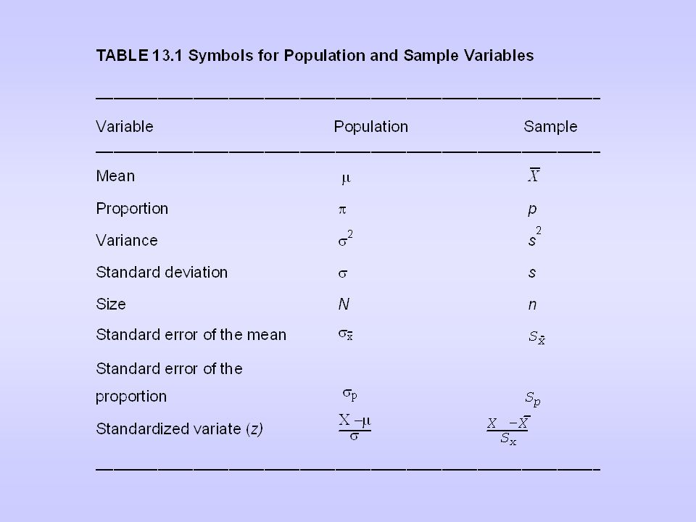

Задача 2.

data=read.csv(file="E:/chi2test1.csv", header=FALSE, sep=",")

data=read.table(file="E:/chi2test1.csv", header=FALSE, sep=",")

chisq.test(data$V1,data$V2)

Chi-square test basics

* Null hypothesis (H0): the row and the column variables of the contingency table are independent.
* Alternative hypothesis (H1): row and column variables are not independent.

Задача 3.

data= read.table(file="E:/Reg21.csv", header=FALSE, sep=",")

data.lm=lm(V1~V2+V3+V4+V5+V6,data=data)

summary(data.lm)

(p-value – маленький -> SIGNIFICANT, если >.05% то можно исключать)

normalTest(data.lm,method="jb")

normalTest(data,method="jb")

Задание 4.

data= read.table(file="E:/Pred21.csv", header=FALSE, sep=",")

train=data[0:1498,]

train.glm=glm(V1~V2+V3,data=train,family=binomial)

summary(train.glm)

p-value маленький -> signigicant значение (S.E. \* 1.95)